**DOCUMENTATION OF PROGRESS**

**Initialization, add README, and .gitignore:**

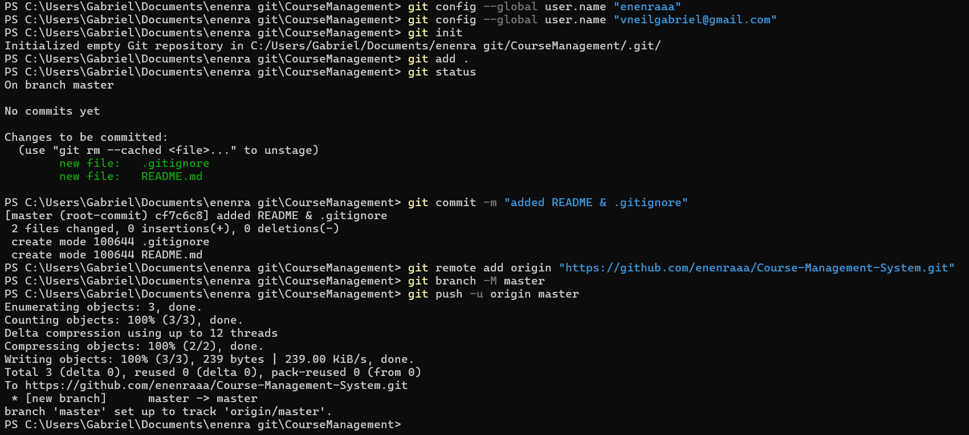

**DOCS**

Requirements branch:

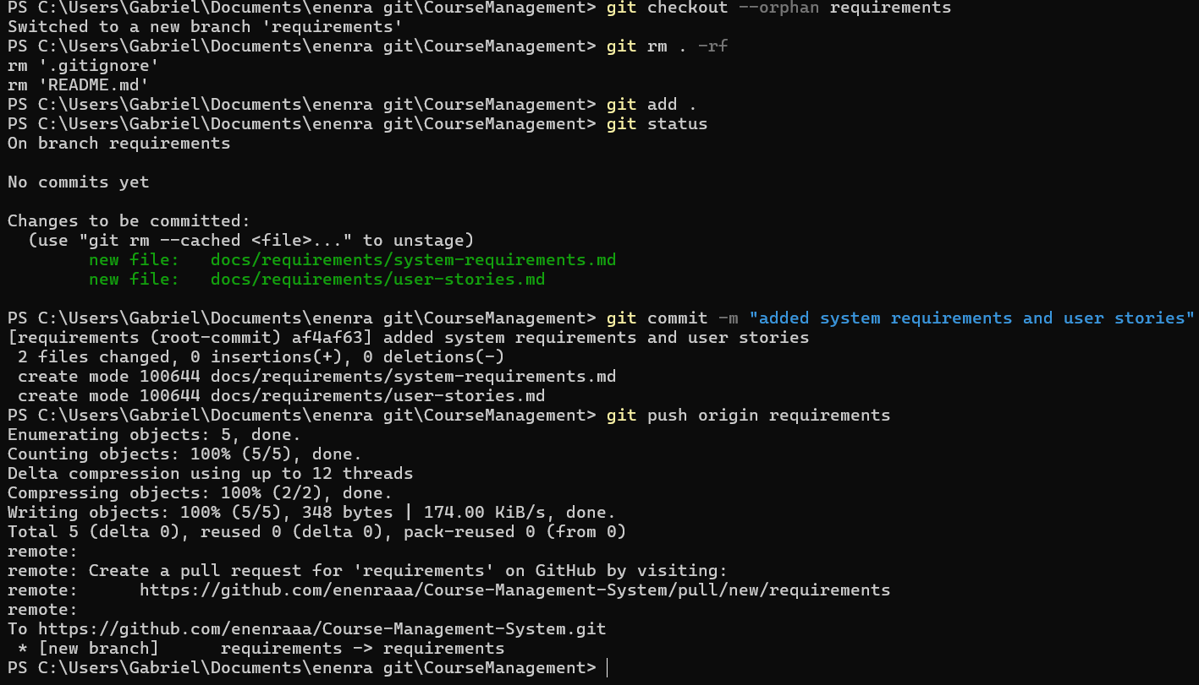

Setup branch:

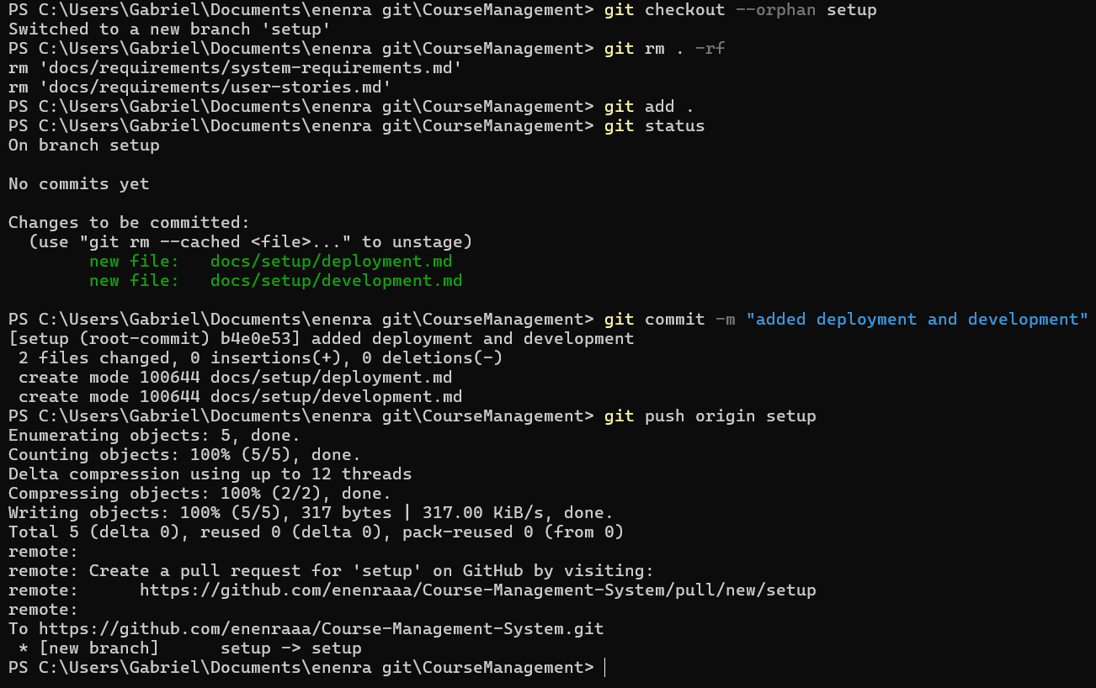

Guidelines branch:

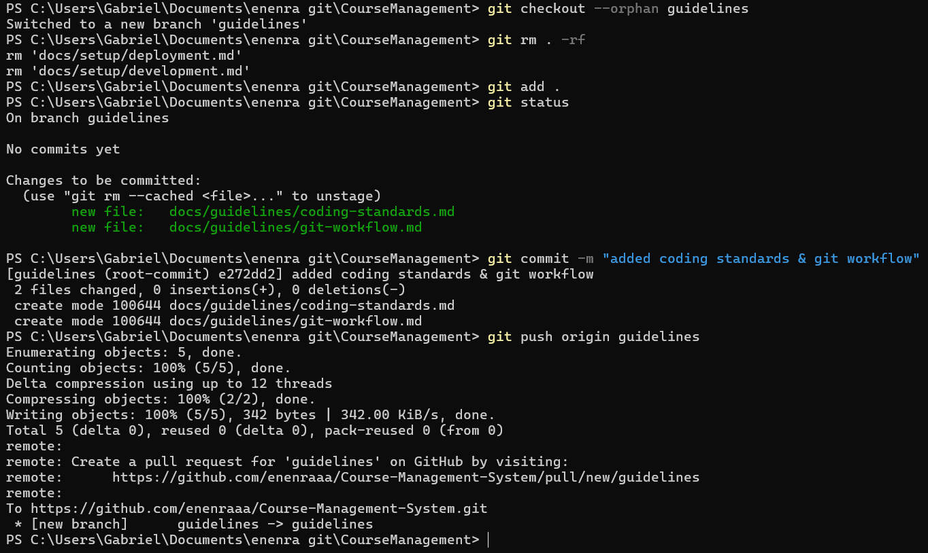

**SRC**

**UNDER API**

Controllers branch:

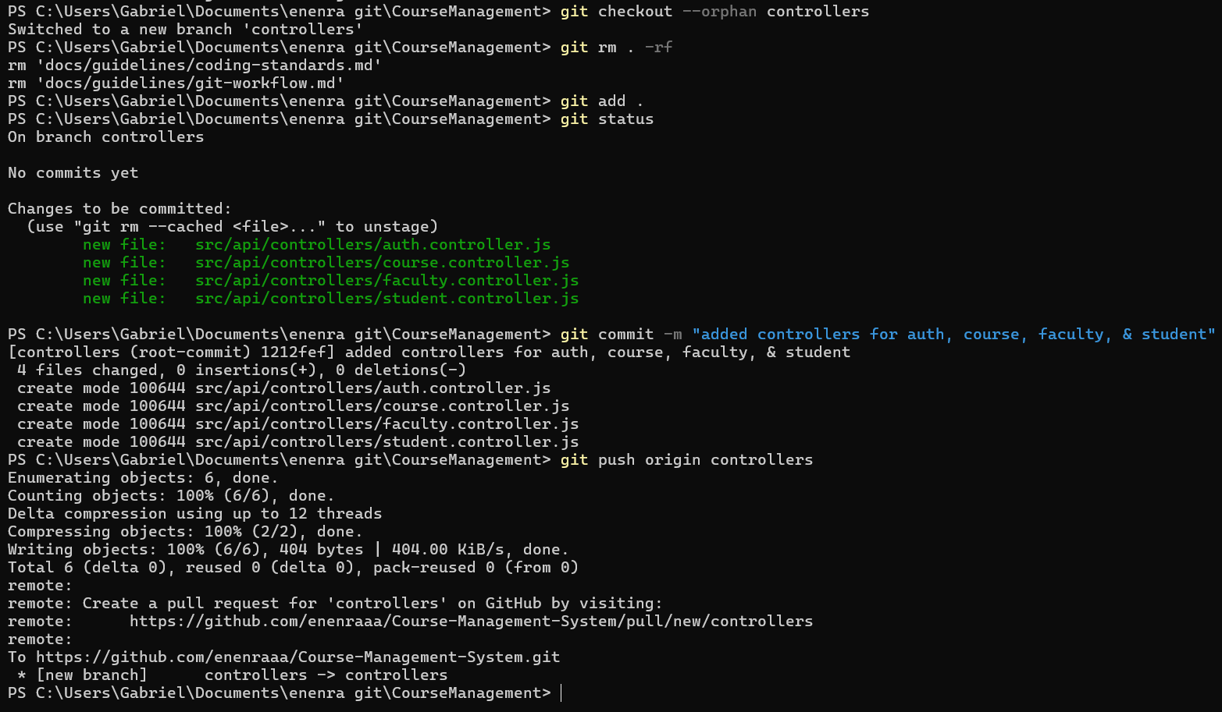

Middleware branch:

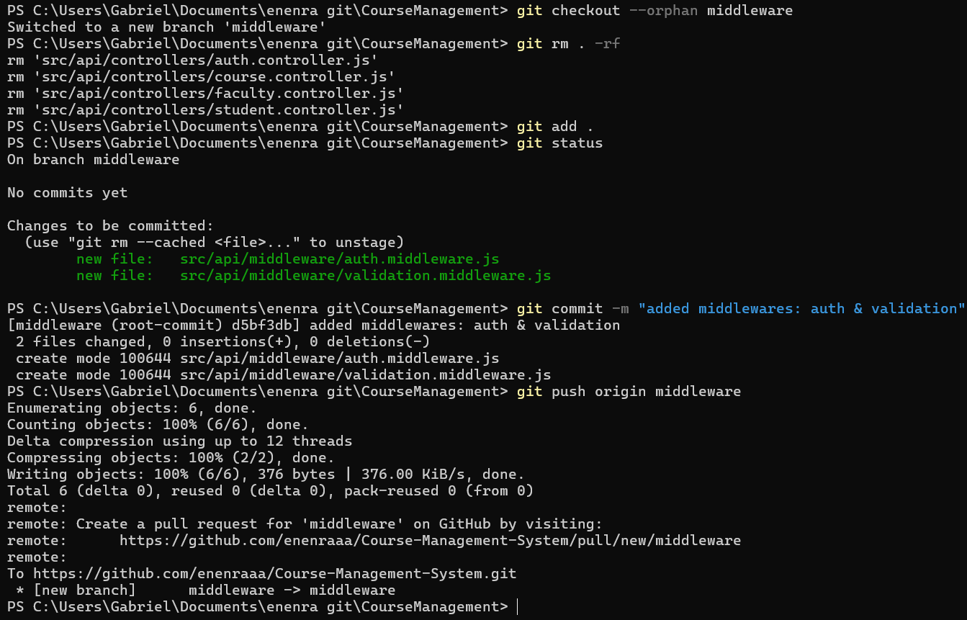

Routes branch:

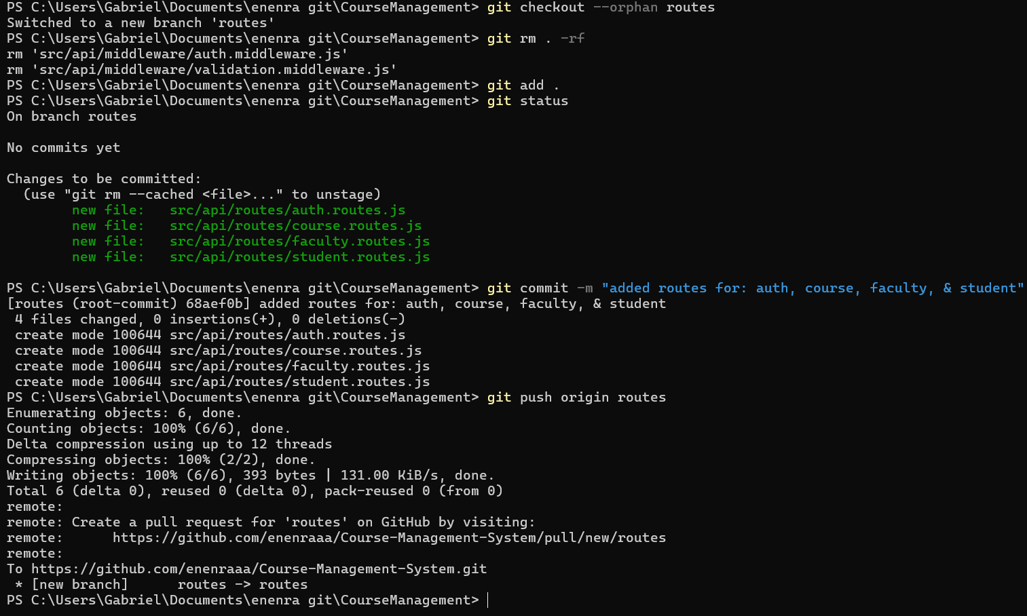

Validators branch:

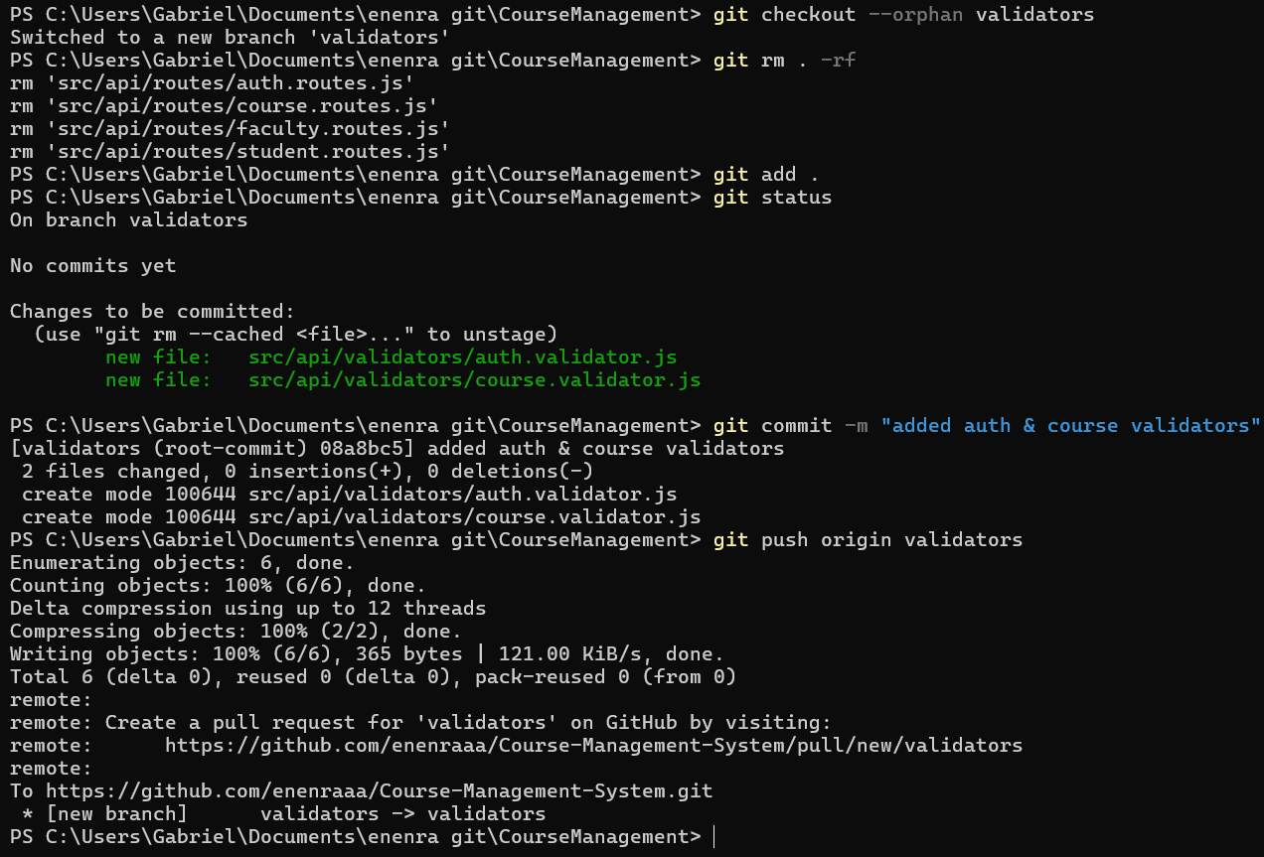

END OF BRANCHES UNDER API FOLDER

Config branch:

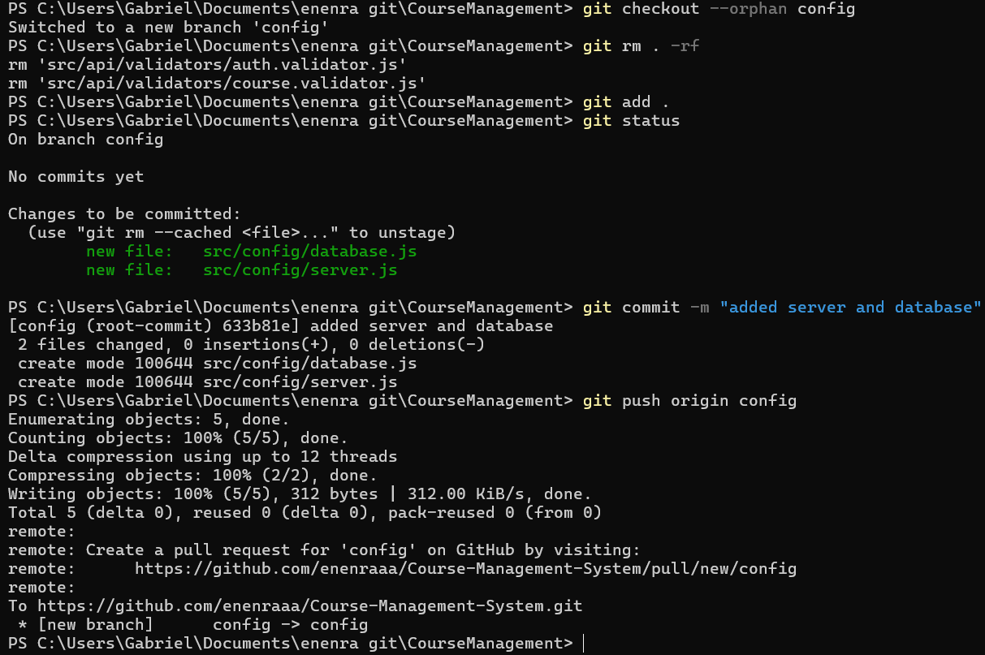

Models branch:

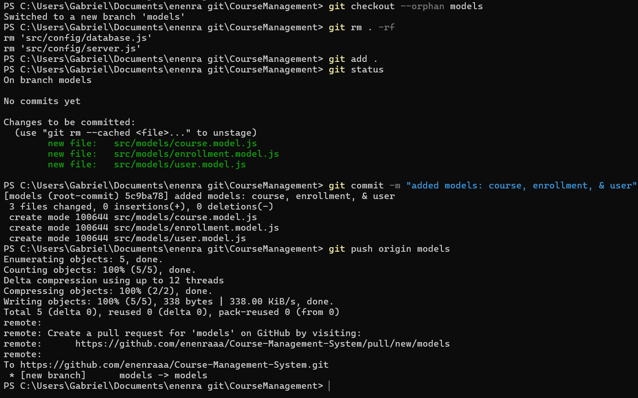

Services branch:

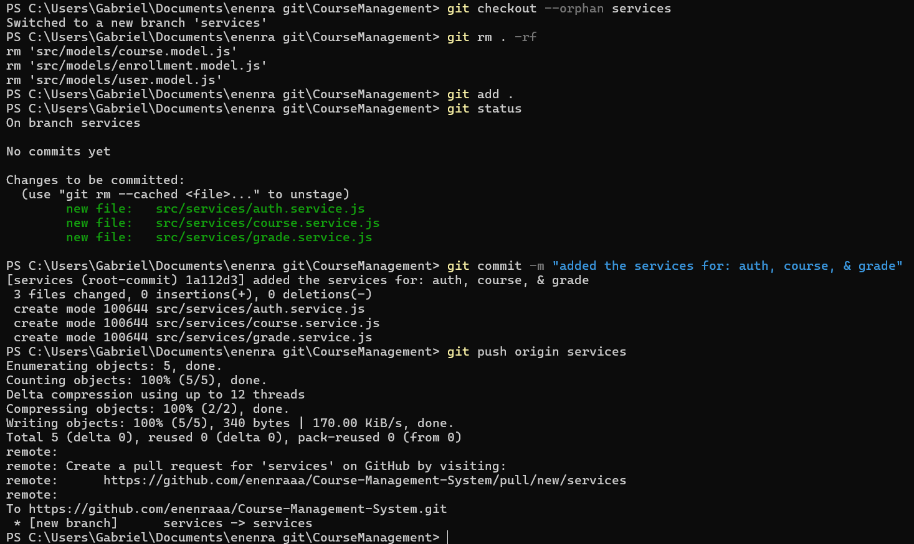

Utils branch:

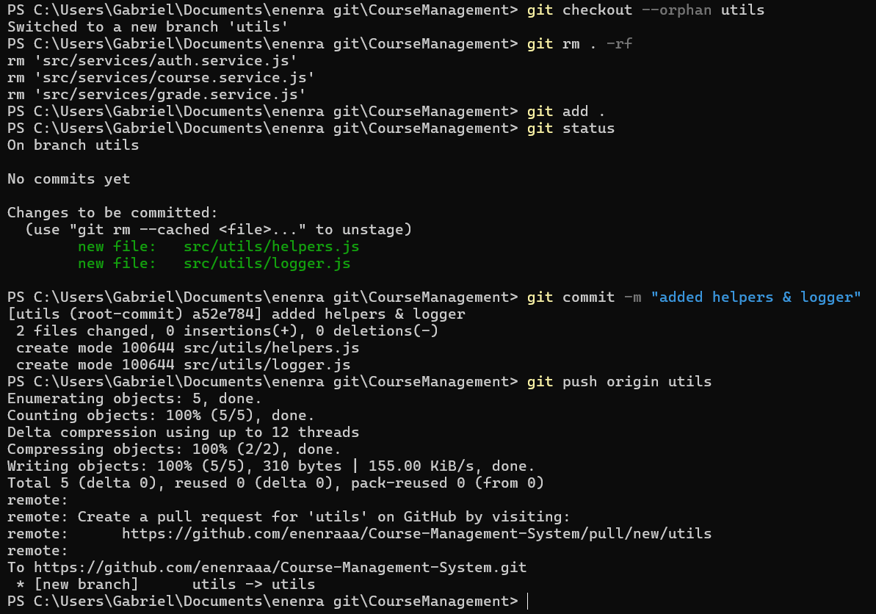

**TESTS**

Unit branch:

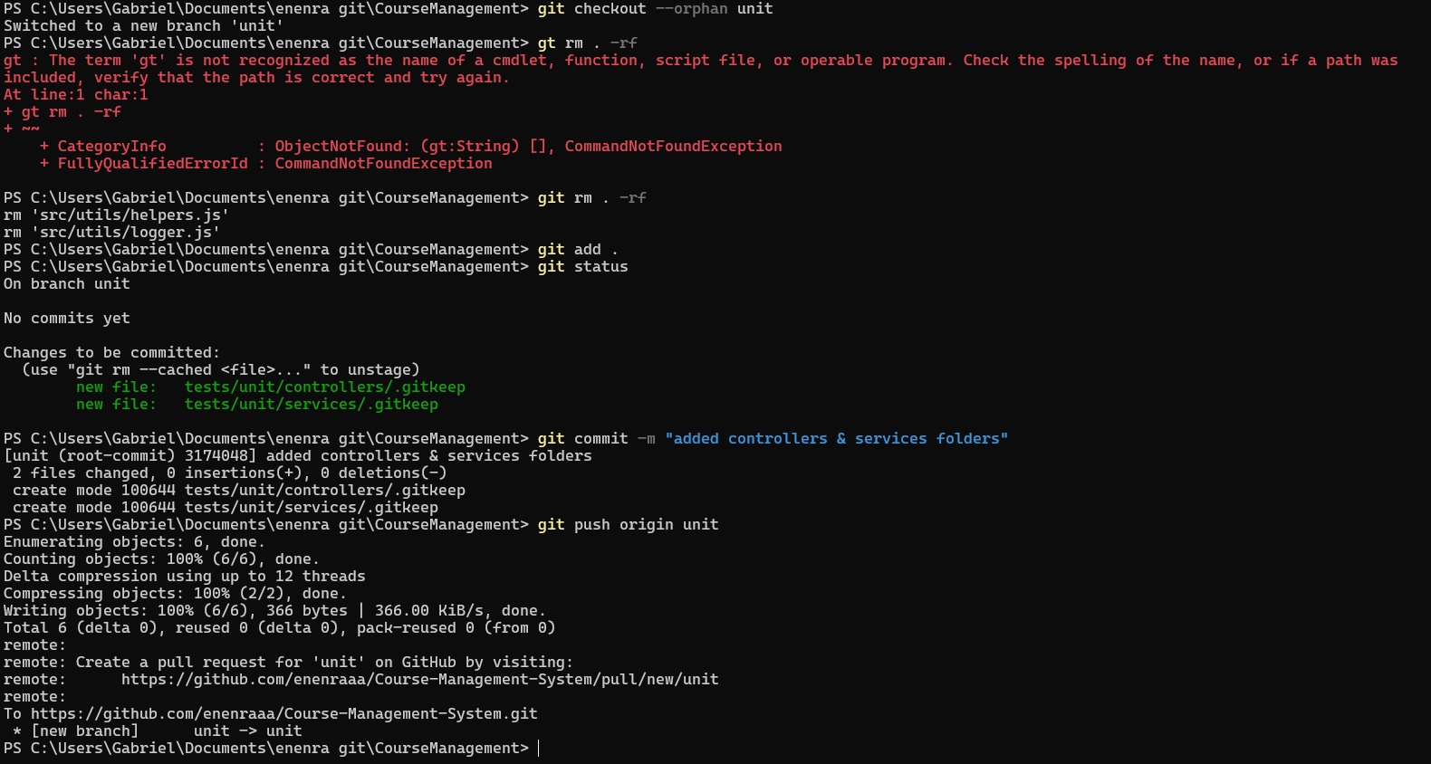

Integration branch:

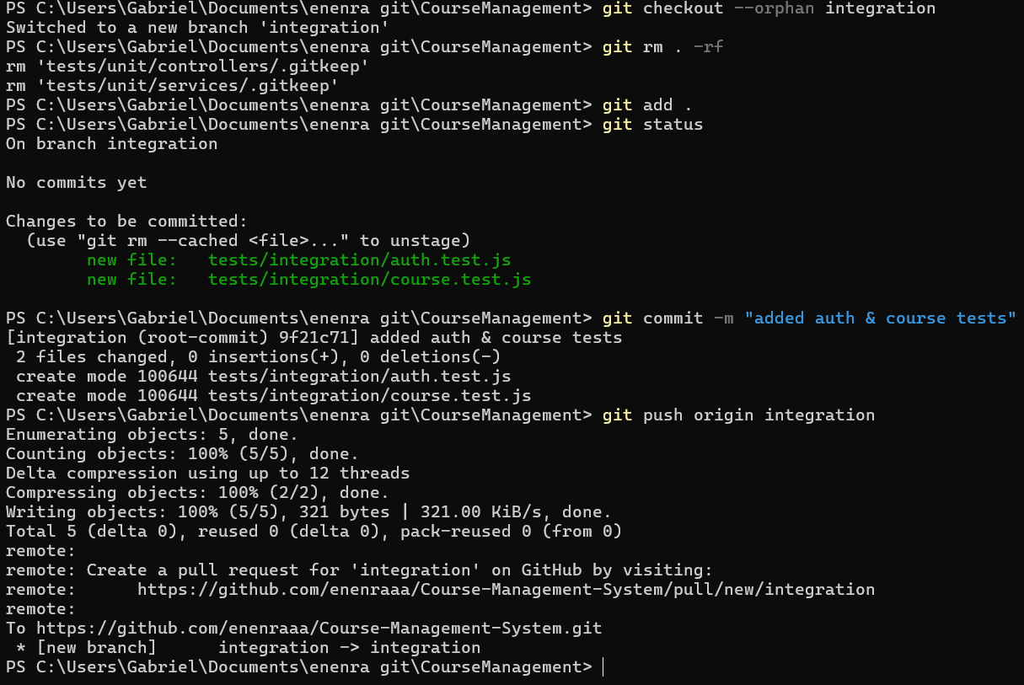

Other files in master branch:

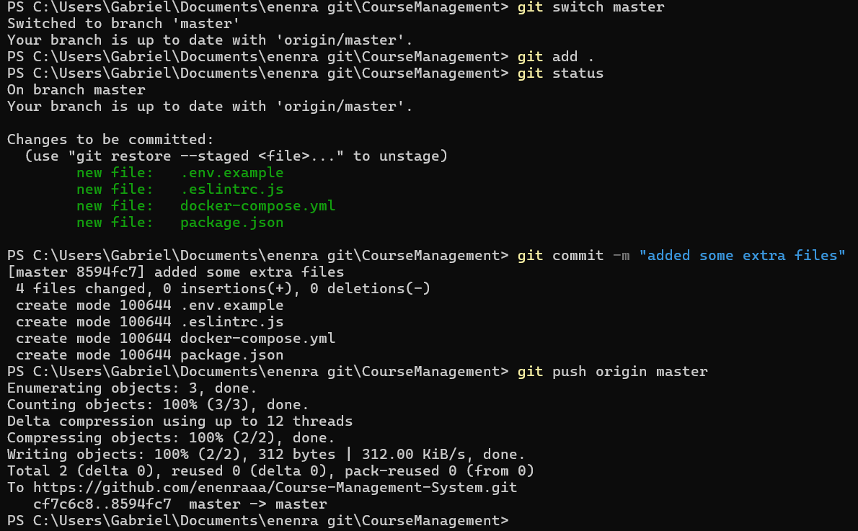

**MERGING BRANCHES TO MASTER BRANCH**

Config branch:

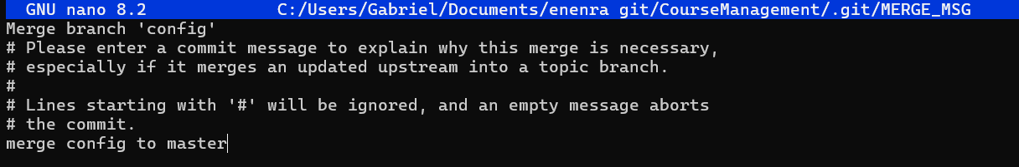

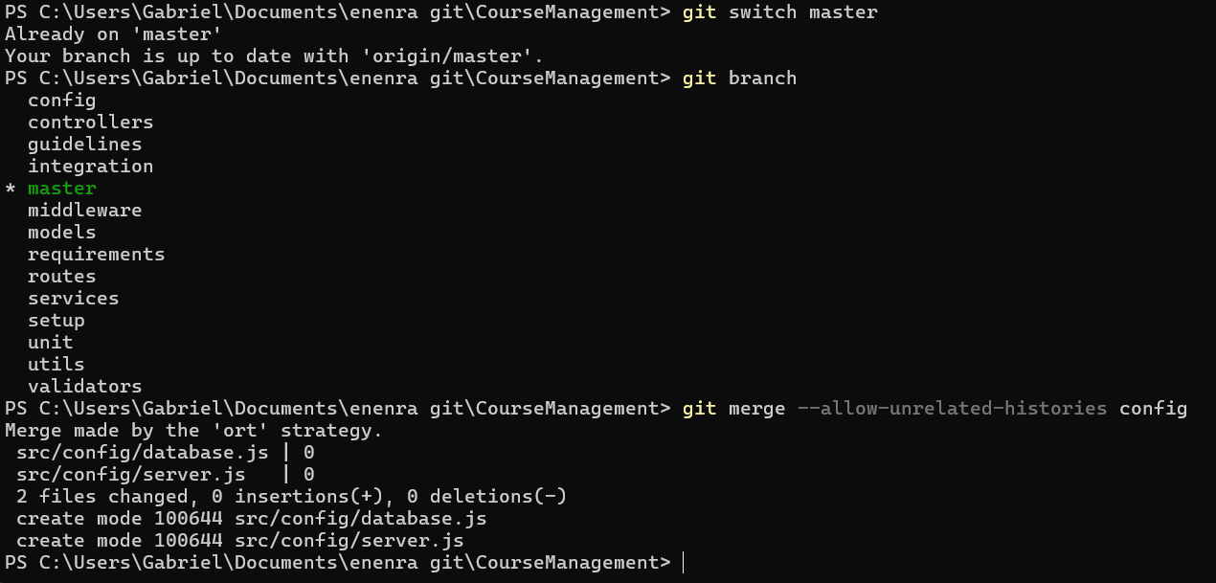

Controllers branch:

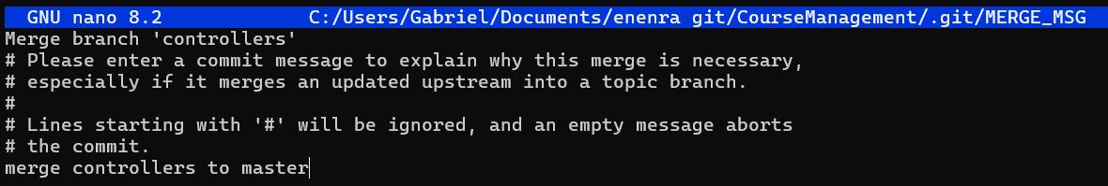

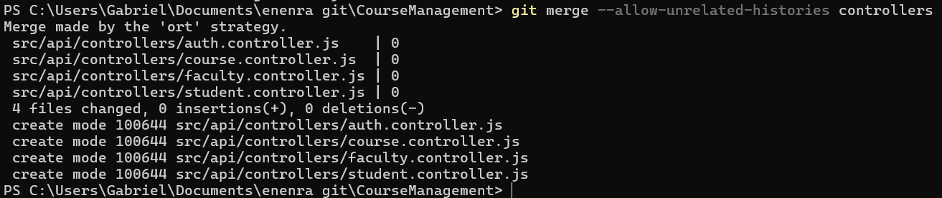

Guidelines branch:

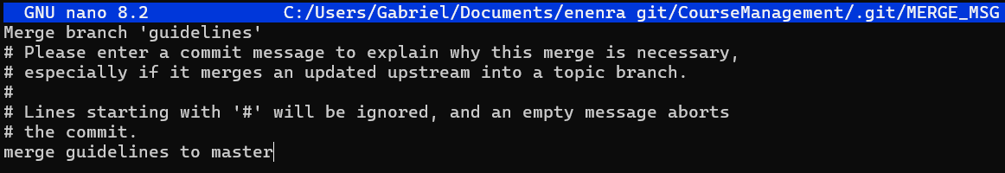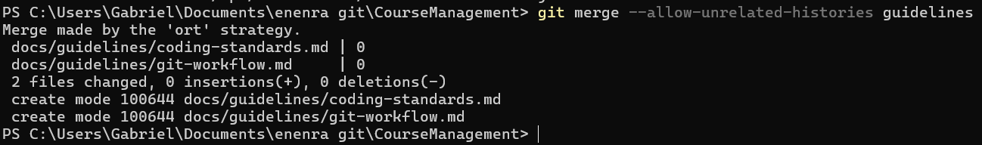

Integration branch:

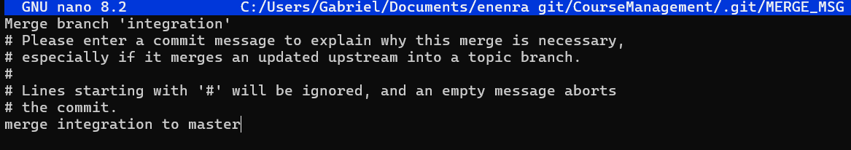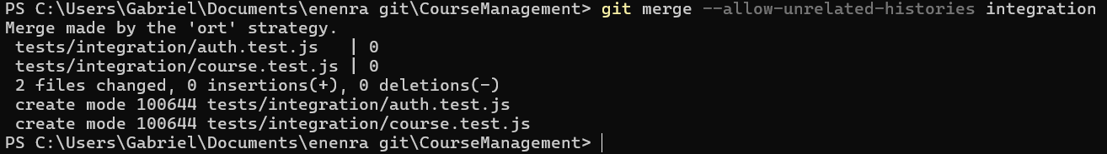

Middleware branch:

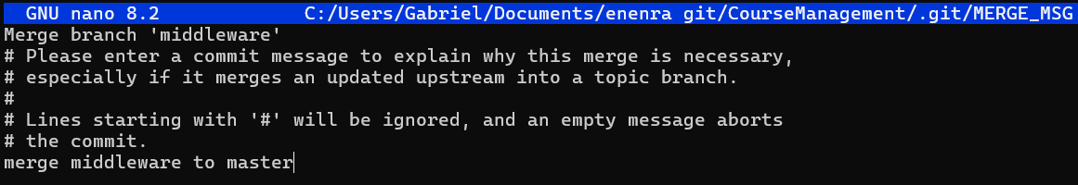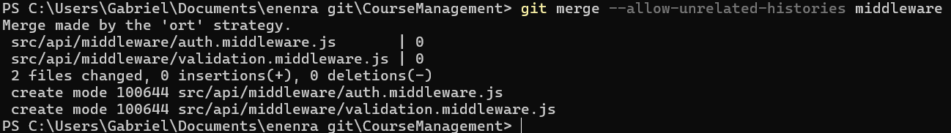

Models branch:

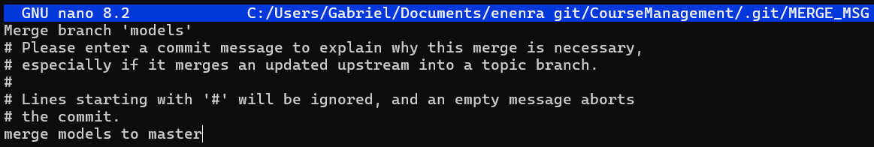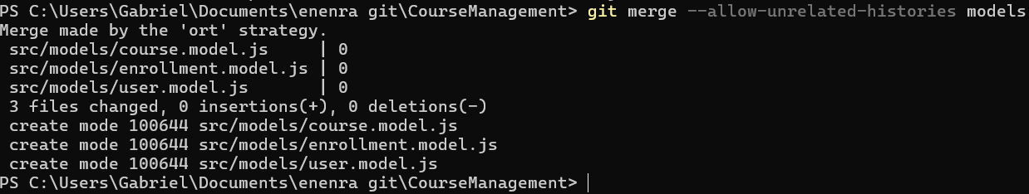

Requirements branch:

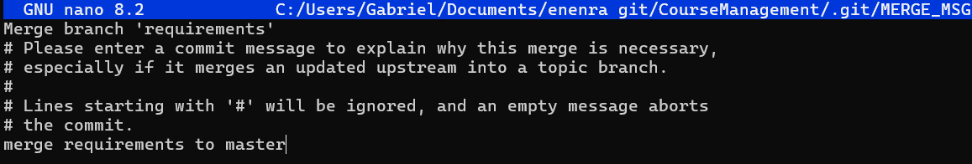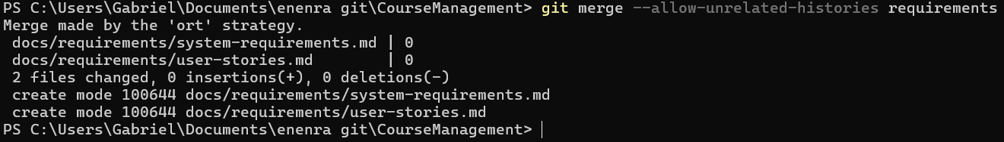

Routes branch:

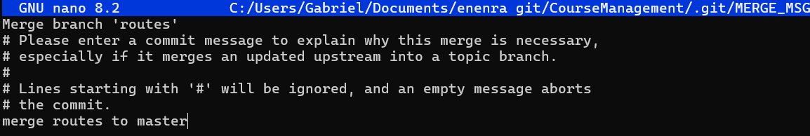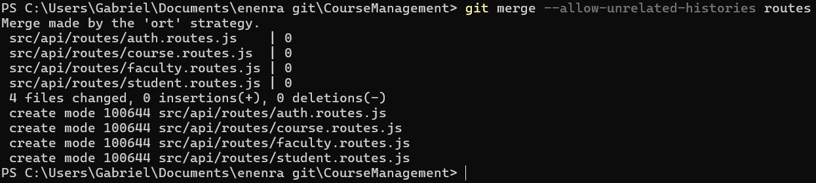

Services branch:

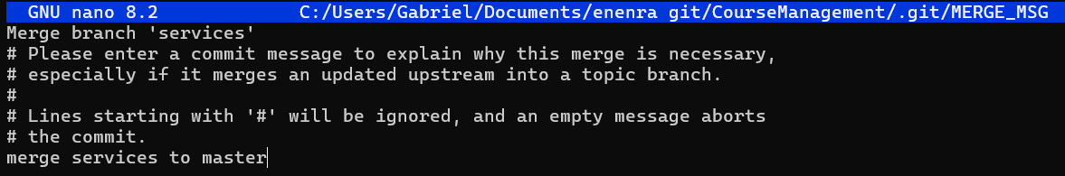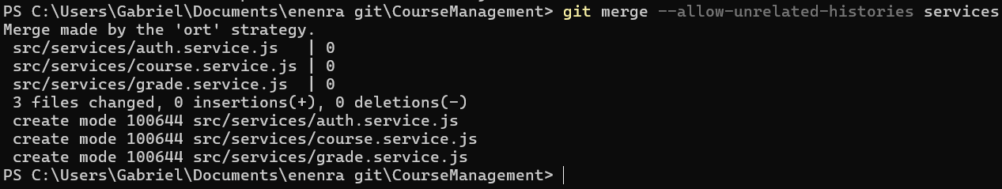

Setup branch:

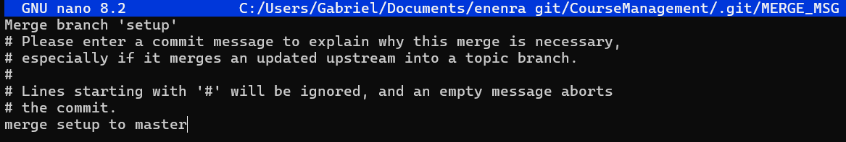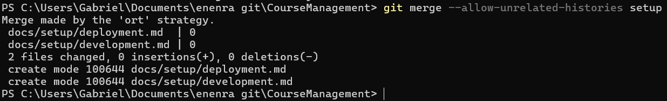

Unit branch:

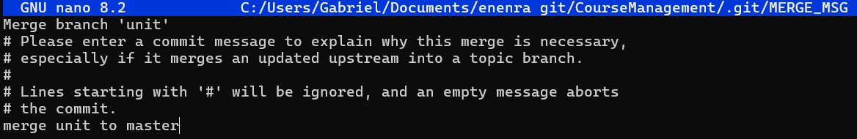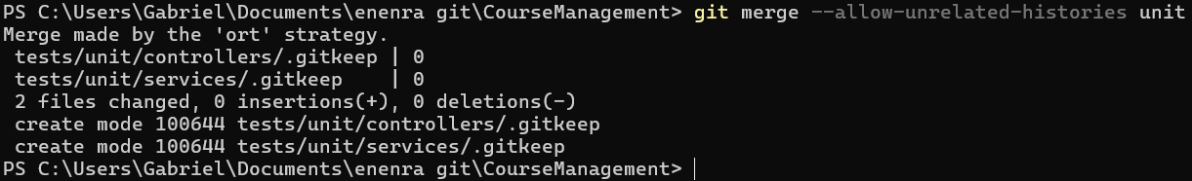

Utils branch:

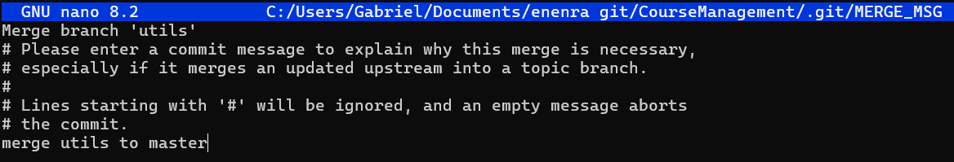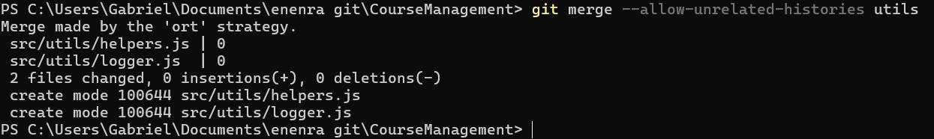

Validators branch:

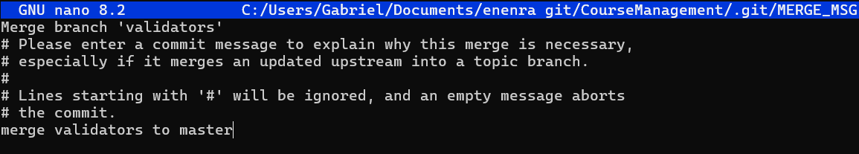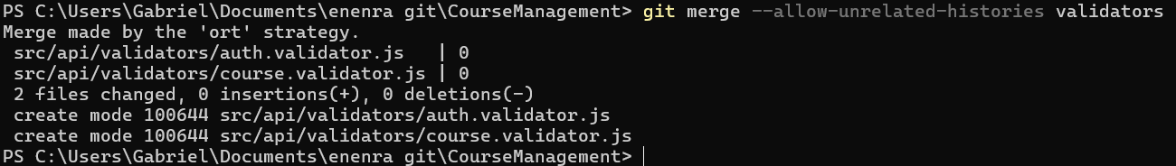

**PUSHING BRANCHES TO MASTER:**

